Risk Identification

🔹 Definition
# Source: AI Source: Provided by: [Data Path: Persons Table -> ID Column: 1, Name_En Column: Motasem Essam] -> From: [Chatgpt (GPT‑5 Mini)] on [8/24/2025]
Risk Identification is the process of recognizing and documenting potential risks that could affect a project, product, or business objective.
It is the first step in the risk management process and sets the foundation for analysis and control.

🛠️ Objectives of Risk Identification
# Source: AI Source: Provided by: [Data Path: Persons Table -> ID Column: 1, Name_En Column: Motasem Essam] -> From: [Chatgpt (GPT‑5 Mini)] on [8/24/2025]
- Discover all possible risks before they impact the project.
- Categorize risks into types (project, product, technical, business, external).
- Provide input for risk analysis, prioritization, and mitigation planning.
- Enable proactive risk management instead of reacting to issues after they occur.

🔹 Techniques for Risk Identification
# Source: AI Source: Provided by: [Data Path: Persons Table -> ID Column: 1, Name_En Column: Motasem Essam] -> From: [Chatgpt (GPT‑5 Mini)] on [8/24/2025]
- Brainstorming
  - Gather team members and stakeholders to list potential risks.
- Expert Judgment
  - Consult experienced team members or industry experts to identify risks.
- Checklists
  - Use predefined lists of common risks from past projects.
- SWOT Analysis
  - Analyze Strengths, Weaknesses, Opportunities, and Threats to identify risks.
- Cause-and-Effect Analysis (Fishbone/Ishikawa)
  - Identify risks based on root causes.
- Delphi / Wideband Delphi Technique
  - Use group consensus from experts to identify and validate risks.
- Historical Data / Lessons Learned
  - Review past project records for recurring risks.

🔹 Attributes Recorded During Risk Identification
# Source: AI Source: Provided by: [Data Path: Persons Table -> ID Column: 1, Name_En Column: Motasem Essam] -> From: [Chatgpt (GPT‑5 Mini)] on [8/24/2025]
- Risk ID / Name
- Description
- Category / Type
- Potential Causes
- Potential Impact
- Owner / Responsible Person

📊 Example Scenario
# Source: AI Source: Provided by: [Data Path: Persons Table -> ID Column: 1, Name_En Column: Motasem Essam] -> From: [Chatgpt (GPT‑5 Mini)] on [8/24/2025]
Project: Online Banking Application
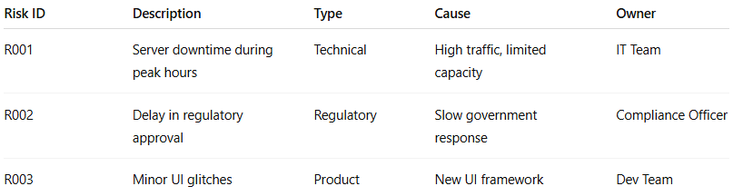
Risk ID | Description | Type | Cause | Owner
R001 | Server downtime during peak hours | Technical | High traffic, limited capacity | IT Team
R002 | Delay in regulatory approval | Regulatory | Slow government response | Compliance Officer
R003 | Minor UI glitches | Product | New UI framework | Dev Team

🔑 Importance of Risk Identification
# Source: AI Source: Provided by: [Data Path: Persons Table -> ID Column: 1, Name_En Column: Motasem Essam] -> From: [Chatgpt (GPT‑5 Mini)] on [8/24/2025]
- Provides a clear view of potential problems early in the project.
- Enables effective planning and mitigation.
- Reduces unexpected surprises and project failures.
- Supports decision-making and stakeholder confidence.

✅ In short:
Risk Identification = The process of discovering and documenting potential risks that may affect a project, product, or business objective.

